Group 9 | Project | Toothbrush Data

**Introduction:**

We have store level data on toothbrushes on various brands collected from different stores across the country. The data includes various demographic features, sales created by them, promotional strategies and information of customers who visited different stores. We as a manager try to analyze the data and make analysis based on competition, other factors to increase the market shares of our brand.

The brands we have used are COLGATE NAVIGATOR and AQUAFRESH FLEX DIRECT.

In today's market to get along with the competition, analysis is mandatory. We need to make sure the important features of our brand are extracted properly and thus helping us in maximizing the sales. Analysis cannot be done based on one attribute/test, it requires multiple inputs and processes to get best possible outcome from the information.

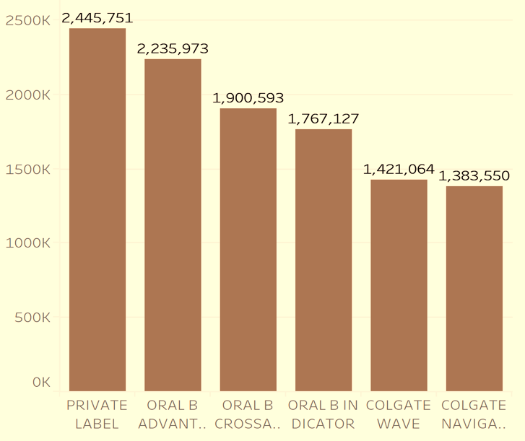

The Top 6 brands according to total sales

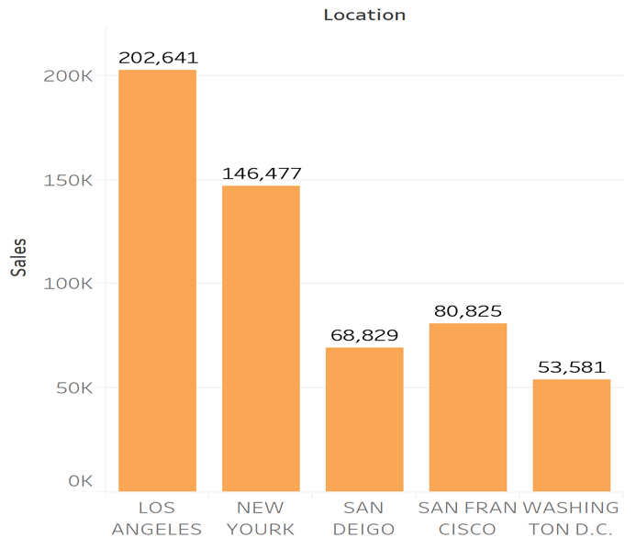  
 Sales with respect to geographic location.

**Statistics:**

ANGLED is the most popular Tooth Brush Type followed by REGULAR, FLEXIBLE and STRAIGHT for total unit sales.

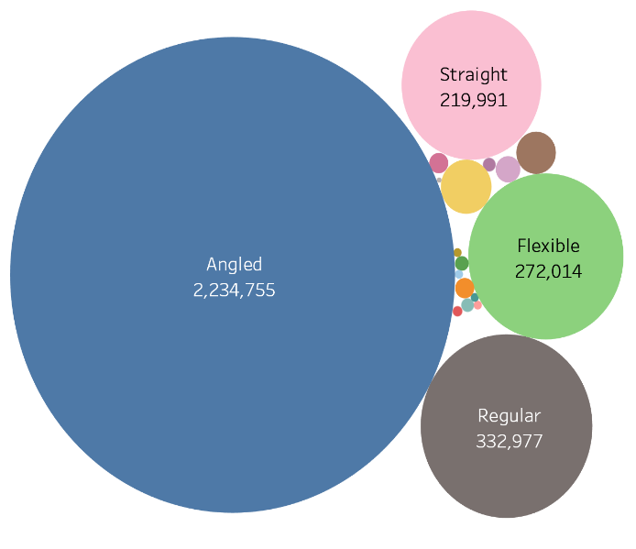

RUBBER GRIP is the most popular Tooth Brush Shape followed by REGULAR, THUMB GRIP and CONTROL GRIP. Below are the Brand level unit sales for Rubber Grip Tooth brush Type

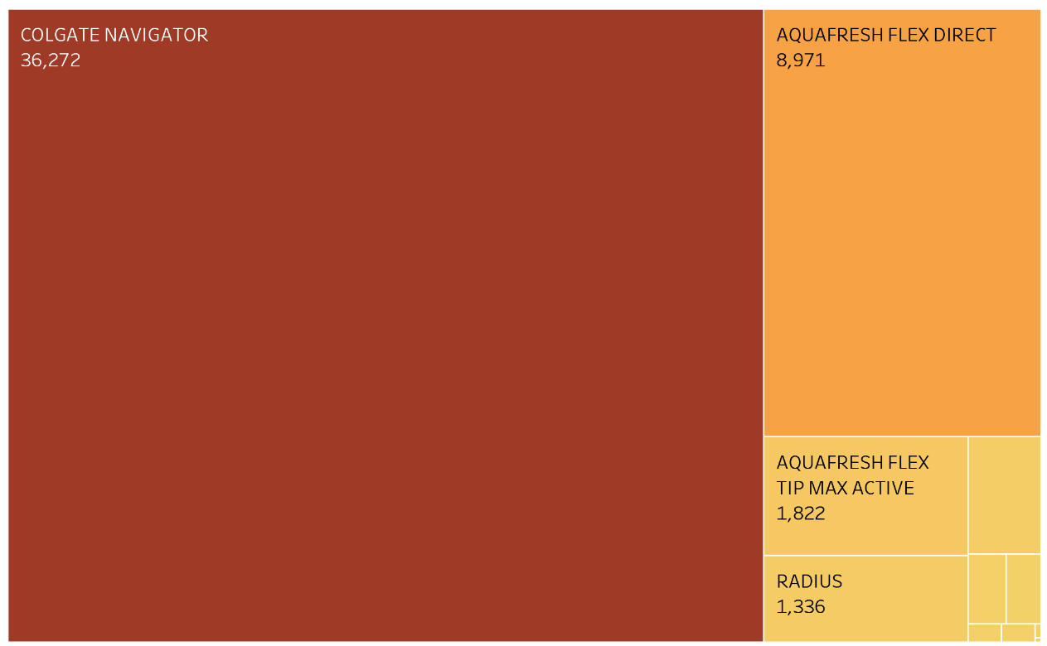

We find COLGATE NAVIGATOR and AQUAFRESH FLEX DIRECT are the most consumed brands with respect to type and shape.

**Market (Location) Analysis for Top 2 Brands (Angled Tooth Brush type and Rubber Tooth Brush Shape)**

Comparing the best geographic locations for COLGATE NAVIGATOR and AQUAFRESH FLEX DIRECT, we find that COLGATE NAVIGATOR has more concentrated market in the West coast, although it has reasonably good sales in East coast as well. Whereas we find that for AQUAFRESH FLEX DIRECT the market in more concentrated near LOS ANGELES. The data is grouped by IRI_Key

TOP 10 STORES for COLGATE NAVIGATOR

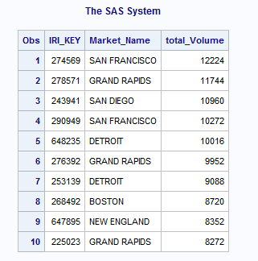

TOP 10 STORES for AQUAFRESH FLEX DIRECT

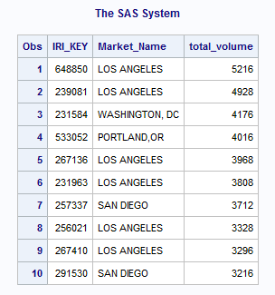

**Sales vs Time (Colgate Navigator)**

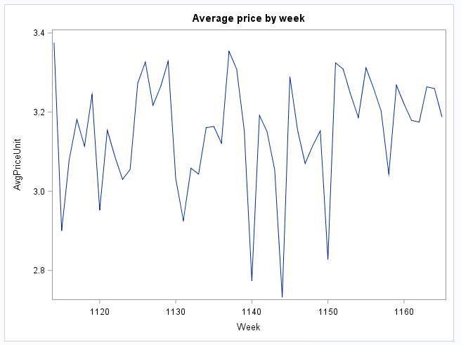

The Time Series for Colgate Navigator brand across the weeks is Stationary.

**PANEL ANALYSIS (FIXED EFFECTS MODEL):**

After running a log-log model we estimated the price elasticity of our brand COLGATE NAVIGATOR and the best rival brand AQUAFRESH FLEX DIRECT against the market share.

The coefficient of price elasticity of COLGATE NAVIGATOR is -1.1 which means that increasing the price by 1% would reduce the sales by 1.1%.

With minor changes in display the sales could increase significantly by 1%. As expected, increase in length of ads increases the sales.

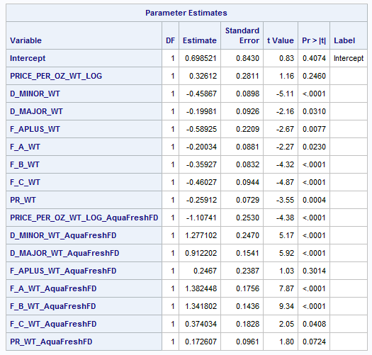

**CLUSTER ANALYSIS:**

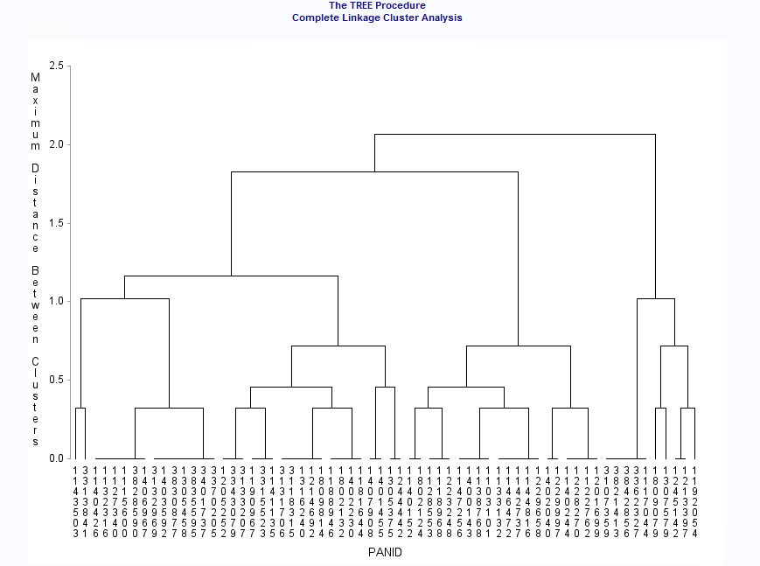

We performed RFM analysis on the dataset to segment our customers based on RFM scores and to identify those customers who are likely to respond to our campaigns and promotions. The panel data for grocery stores was combined with the product data to identify the brands chosen by different panelists. We ran RFM analysis on household panel data taking Number of TV’s hooked to cable, Income, Marital Status, Number of Children, Family Size, Male Smokers and Age into account. All our customers are divided into 5 clusters.

The results indicate that Aqua Fresh’s loyal customers (33%) are aged 42 years and above with mostly no male smokers in the households. This is the segment which is responsive to promotions and should be rewarded to sustain market share. The segment to focus on is the medium to high income group with family size of more than 4, we can engage them by offering coupons or free samples of the product.

**RECOMMENDATION:**

* Looking at the current market we find out that despite our prices the sales of our product is good when compared to similar types of brushes.
* We should try to increase our Market towards the East Coast as well.
* Implementing large sized advertisements has helped increase our sales in West and we can do the similar strategy in East Coast.
* We should focus more on current running type of our toothbrushes which are more popular.
* Toothbrushes are such a commodity in which people’s choice do not vary across different geographical demographic factors and thus we should keep increasing the production of ANGLED and RUBBER GRIP Brushes
* Medium income groups with age group (30-55) are our target customers which is also intuitive as this age group purchases the most for household. Moreover, toothbrush is a necessity product and respective of income people to buy it.